**Deploy in Kubernetes Cluster**

|  |  |
| --- | --- |
| Date | 19 November 2022 |
| Team ID | PNT2022TMID12566 |
| Project Name | News Tracker Application |

**deployment.yaml:**

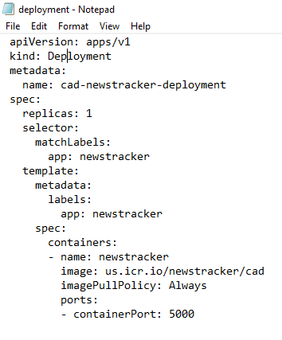

Enter *ibmcloudks cluster config -c <cluster_id>* to connect with the kubernetes cluster created in the IBM Cloud.

Then execute this command*Create -f deployment.yaml*

After deploying, expose the application to public using the command;kubectl expose deployment news-tracker-1--type=NodePort --name=news-tracker-1

**Kubernetes Cluster Worker Node**

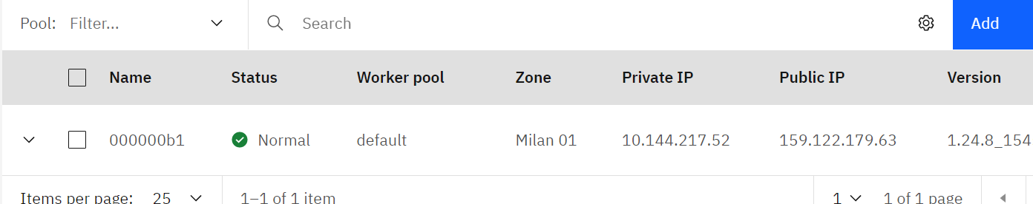

**Kubernetes Dashboard**

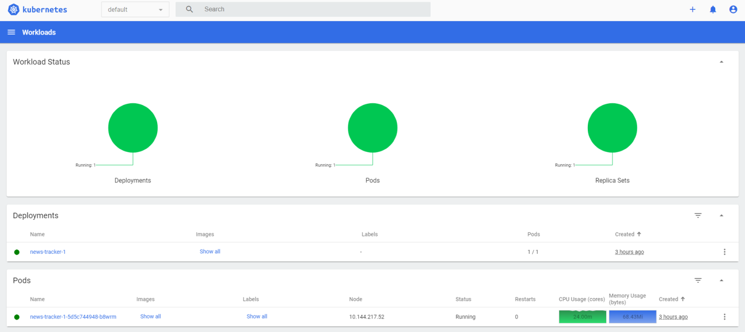



**Application running on IBM Kubernetes Cluster**

